CENL – Spindle manual extraction protocol. Last edit 3/2021

**This cutting protocol was used in the following publication:**

**Ground Truth Construction and Parameter Tuning for the Detection of Sleep Spindle Timing in Rodents**. Harper B and Fellous JM. J. Neuroscience Methods, Feb 1;313:13-23. doi: 10.1016/j.jneumeth.2018.11.023, 2019.

http://amygdala.psychdept.arizona.edu/data/JNM2018SpindlePage/SpindlePage.html

**Introduction**: Spindles are short episodes of oscillatory activity resulting from reverberations between cortex and thalamus during slow wave sleep. In the rat, they include a characteristic period of 11-15 Hz oscillatory activity. They are often accompanied by an initial K-complex, a large downward deflection in the LFP, also called a ‘down-state’.

Because of their short nature, their variability, and the relatively low frequency of the oscillations, they are notoriously difficult to detect automatically. In order to obtain good quality quantitative assessments of the properties of spindles, and to provide a ‘ground truth’ to algorithms for spindle detection (i.e. a ‘no-error’ detection dataset), we need the human eye.

This document sets forth general rules and guidelines for manual spindle identification from LFP records, and for assessing their ‘quality’. It uses our Matlab Function (RateEEG(), use at least 2.0 second windows).

Three graphoelements are identified separately:

- **Spindles** **accompanied by a K-complex** (as described above):

These spindles are categorized by quality. Quality scoring should consider the frequency, duration, and amplitude of the spindle, as well as clarity of the K-complex.

* **Good**: Good features all across.
* **Medium:** Spindle with some noisy features, or where the K-complex is less certain.
* **Bad:** Very likely a spindle, but poor quality.

- **K-less** spindles (spindles with at least 3 cycles of the oscillation, but without detectable K-complex)

- **K-alone** events (K-complexes, without qualifying subsequent spindle cycles)

Examples follow below, with some comments.

**The Matlab Interface**: The function RateEEG.m construct a simple GUI and allows you to browse and mark the Spindles. See the webpage above for instruction on how to start the interface.

* The bottom white **arrows** more the trace right or left. The upper orange **-><-** and **<- ->** buttons zoom the trace window. For we spindle we suggest a 2.4-3.0 sec window size.
* When you find a candidate spindle, click **INSERT**. A red rectangle should appear. Move the left and right edges to the beginning and end of the Spindle (the top and bottom of the rectangle is unused, no need to adjust). Choose a quality (‘good’, ‘medium’, k-alone’… etc). Then click on **Validate**. The rectangle should turn green.
* If you want to reassess the quality of a spindle. First, bring it to view in the wndow. Then choose the new assessment (e.g. ‘Medium’), then click on **Reassess**, then click within the green rectangle of the Spindle. The assessment should change.
* To delete a green rectangle, click **DEL** and then click inside the green rectangle.
* Click **Save** from time to time to save your work
* If you want to view a particular rectangle by itself, click **Snap**, then click on the rectangle. A new window should appear.
* **Previous** and **Next** will move you to the next Spindle (before or after) the current window. If the quality is set to anything else different from ‘none’, you will see the next spindle of that quality (i.e. if quality is ‘good’ then you will skip to the next good spindle before or after the current window, ignoring the other qualities).
* Do not use the **spectrogram** option when scoring spindles.

Good Spindles

 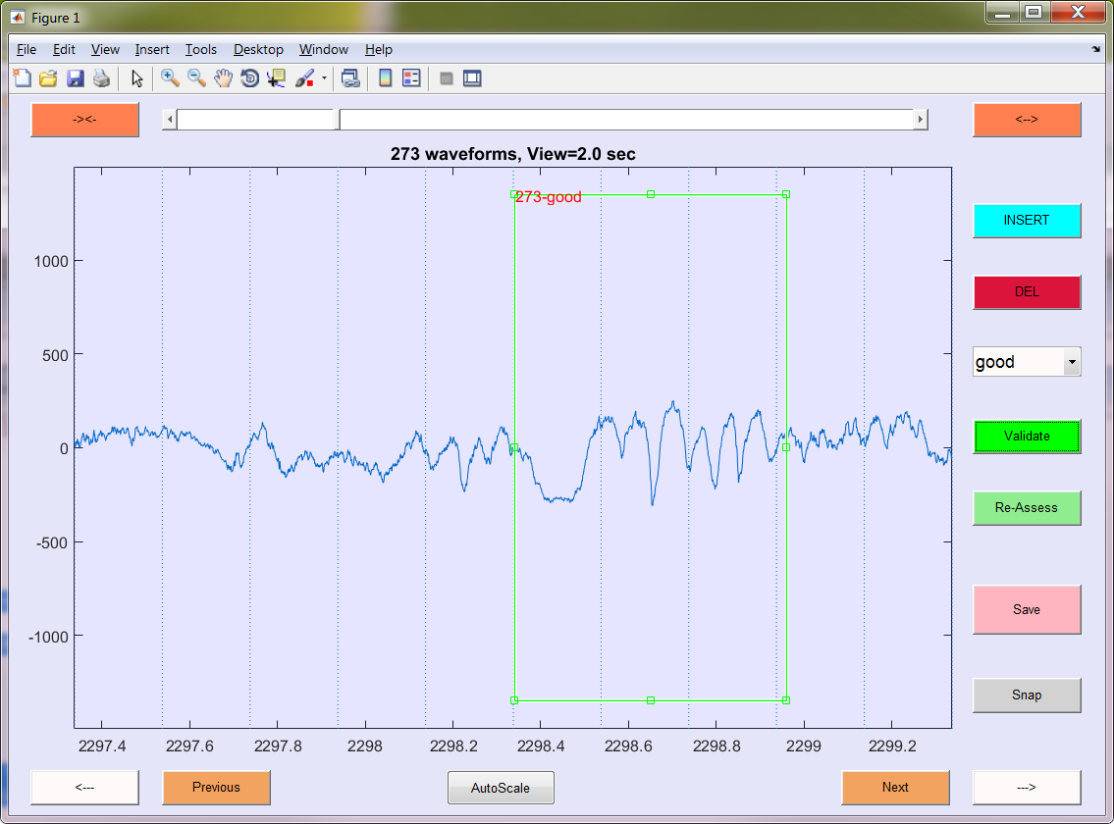 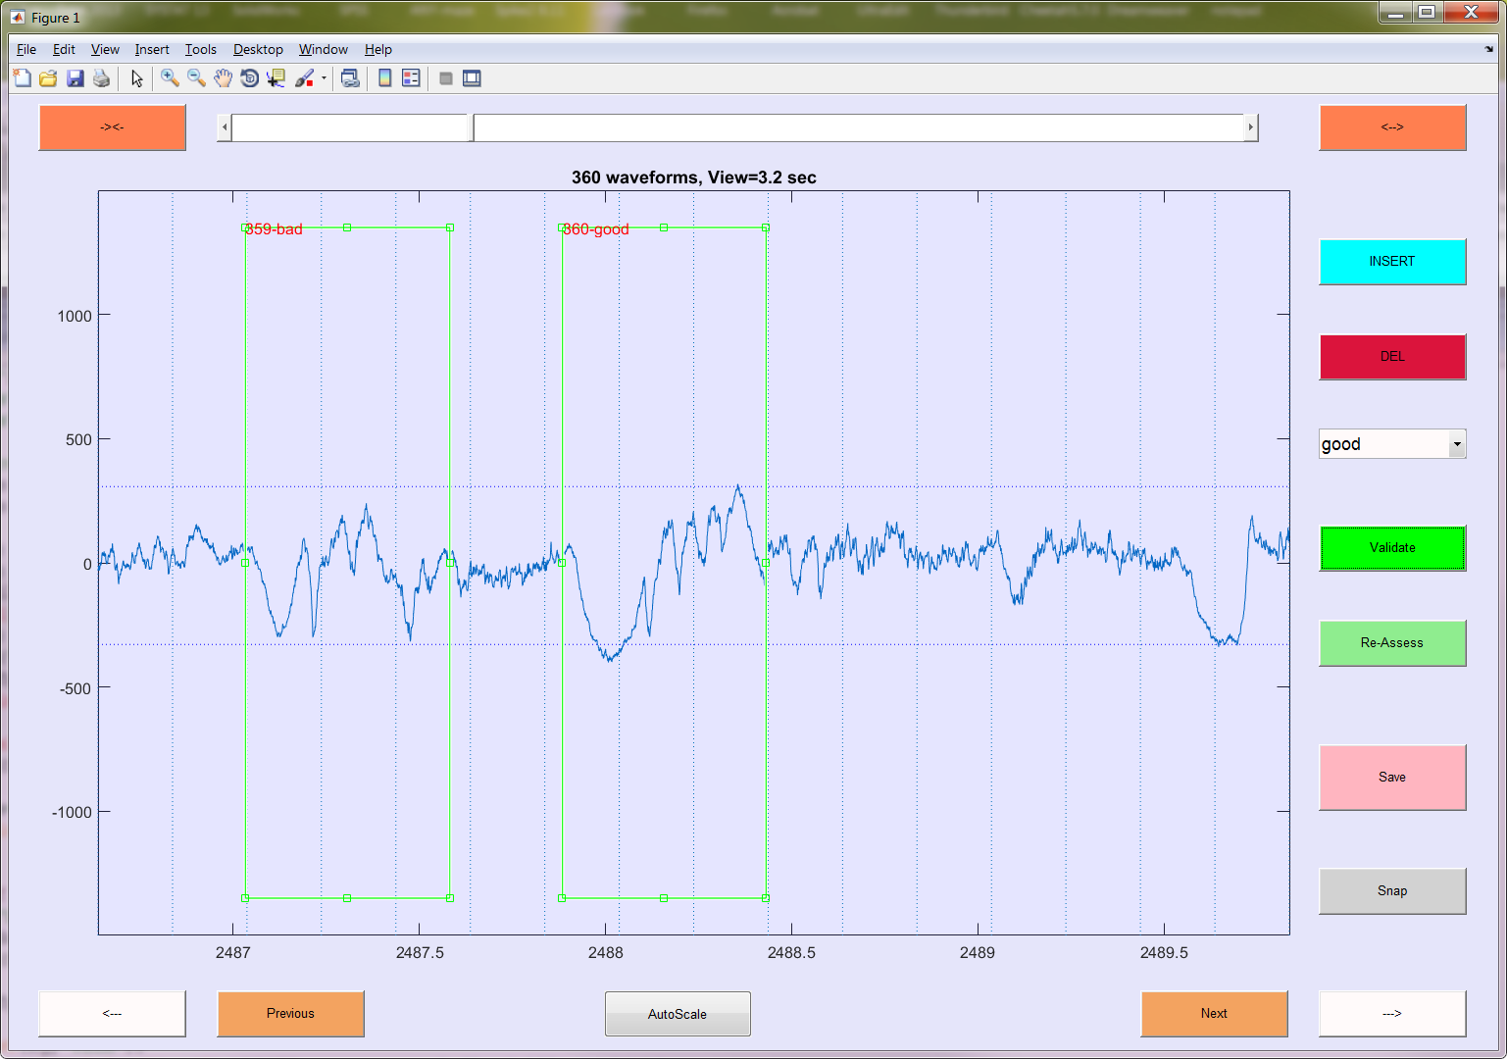 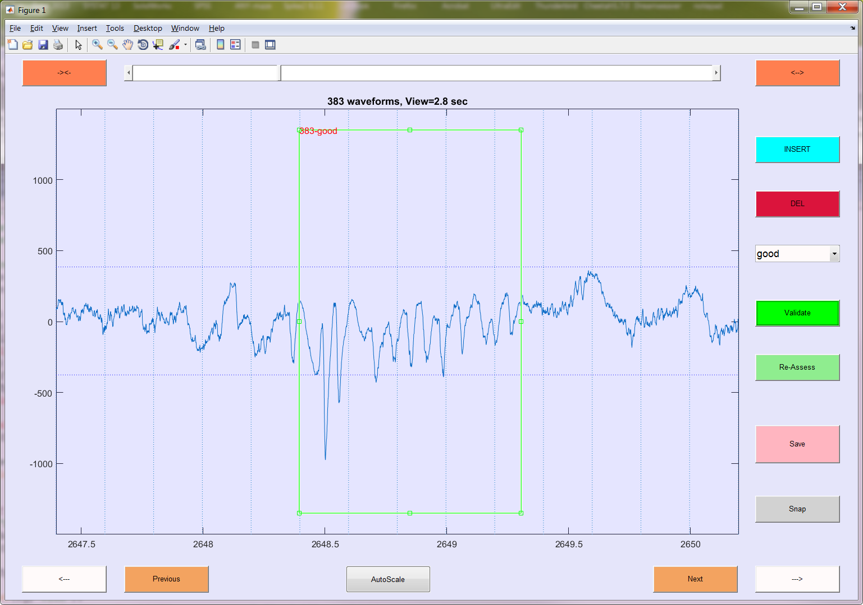

Good spindles. A: note, the K complex has a ‘spike’/‘tooth’ towards the right. B: a few cycles of the spindles before the start of the K-complex, yet the boundary is placed at the start of the K-Complex. There are some very bad cycles after the right boundary; we do not include them. C: Goods can be short and small amplitude, as long as they are well-formed. D: the K-complex has been ‘invaded’ by 2 cycles of oscillations… still good.

Medium

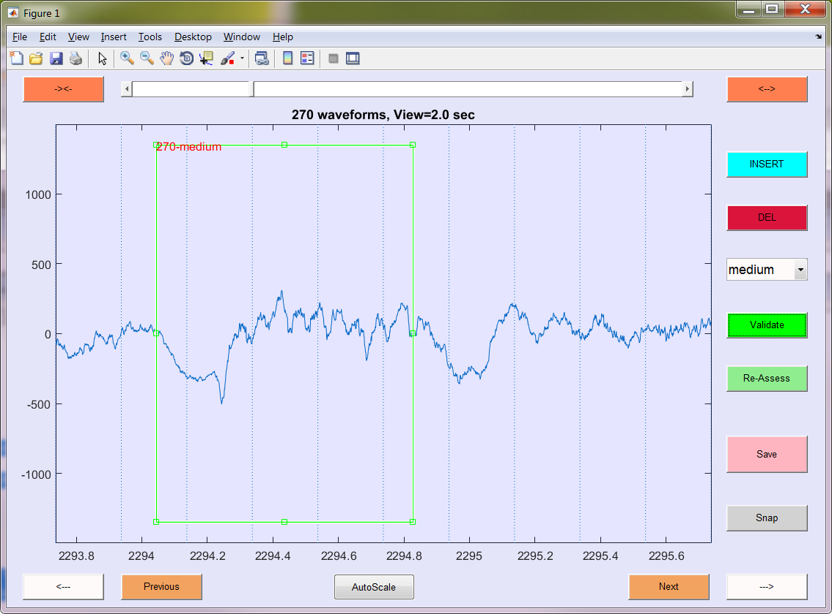 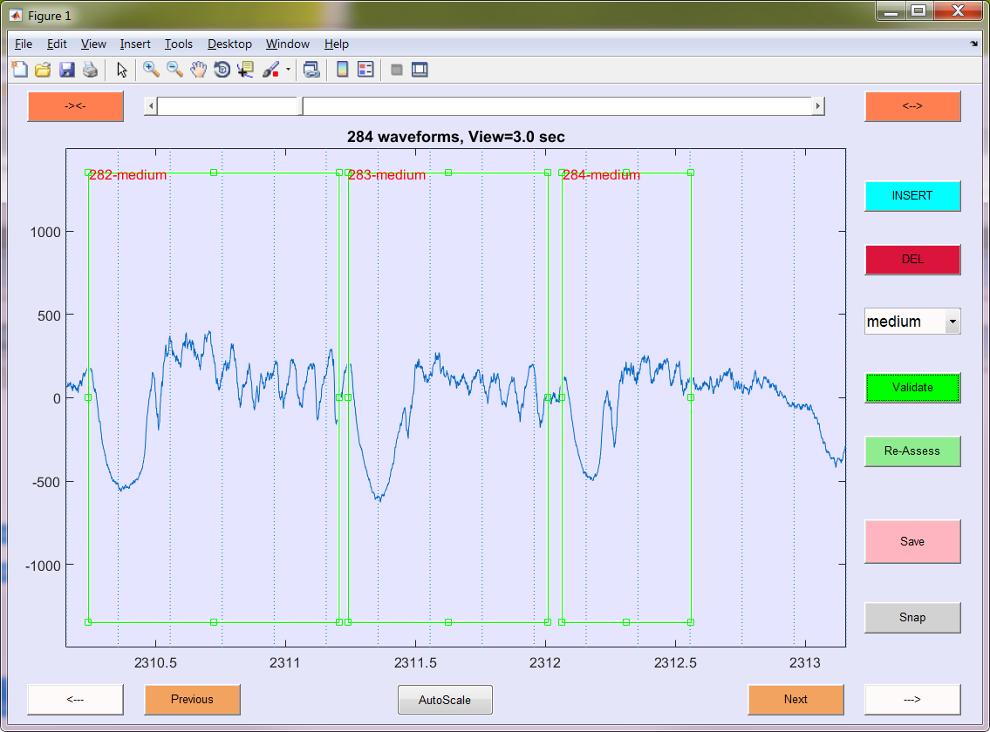 

Medium: A: the oscillations are a bit noisy. The end of the spindle is a bit before the next K-complex. B: Spindles often come in bouts. Do your best to separate them if you can, even if the boundary are very close to each other. Here the first one is almost ‘good’. C: smallish K-complex, irregular amplitude oscillation.

Bad



Bad: appears to be a spindle with a k-complex, but both have low amplitude. The spindle is noisy and missing a cycle or two.

K-Alone

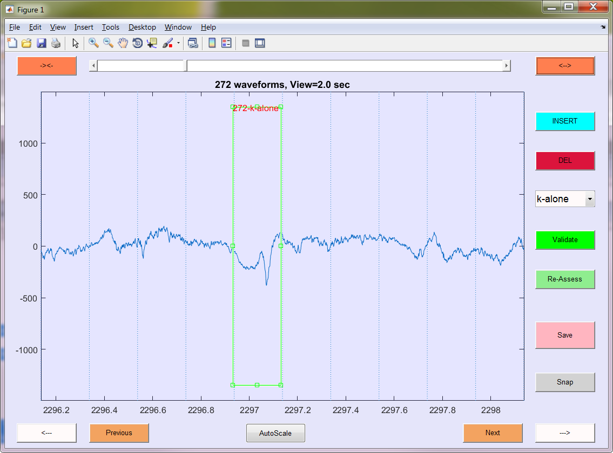 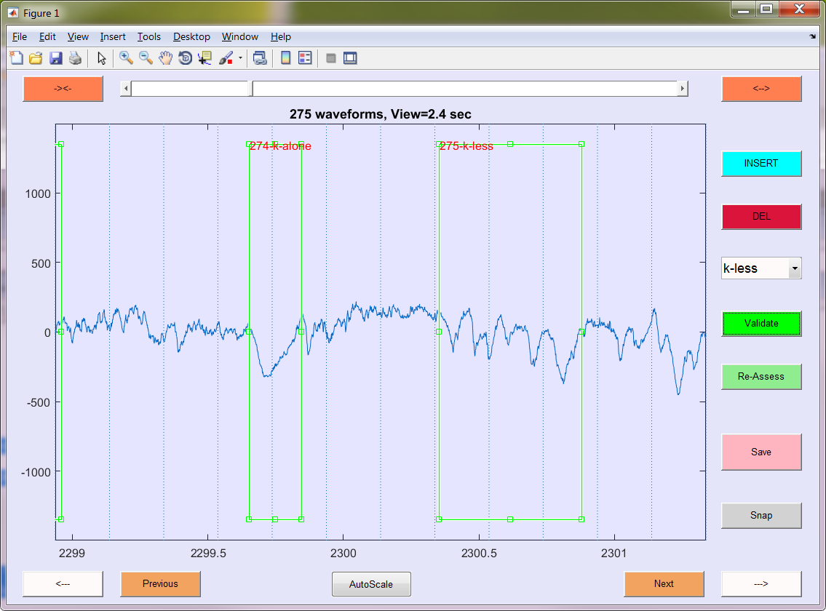 

K-Alone. A: this K-Complex has a ‘spike’. The K-complex is not followed by at least 3 cycles of oscillations (therefore not ‘bad’). B: the K-complex recovers to baseline before the ‘spike’-type activity; the boundary does not include a ‘spike’. C: K-like deflections less than 3 noise STD are ignored.

K-Less

 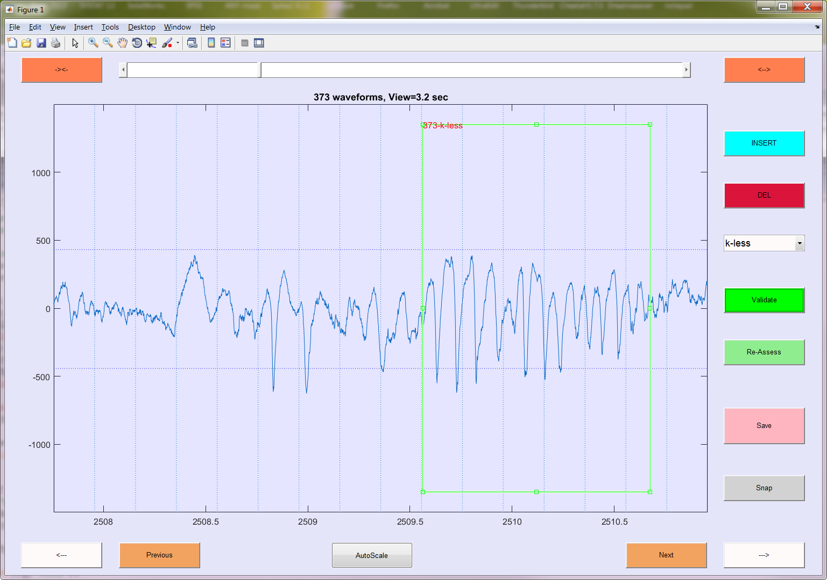

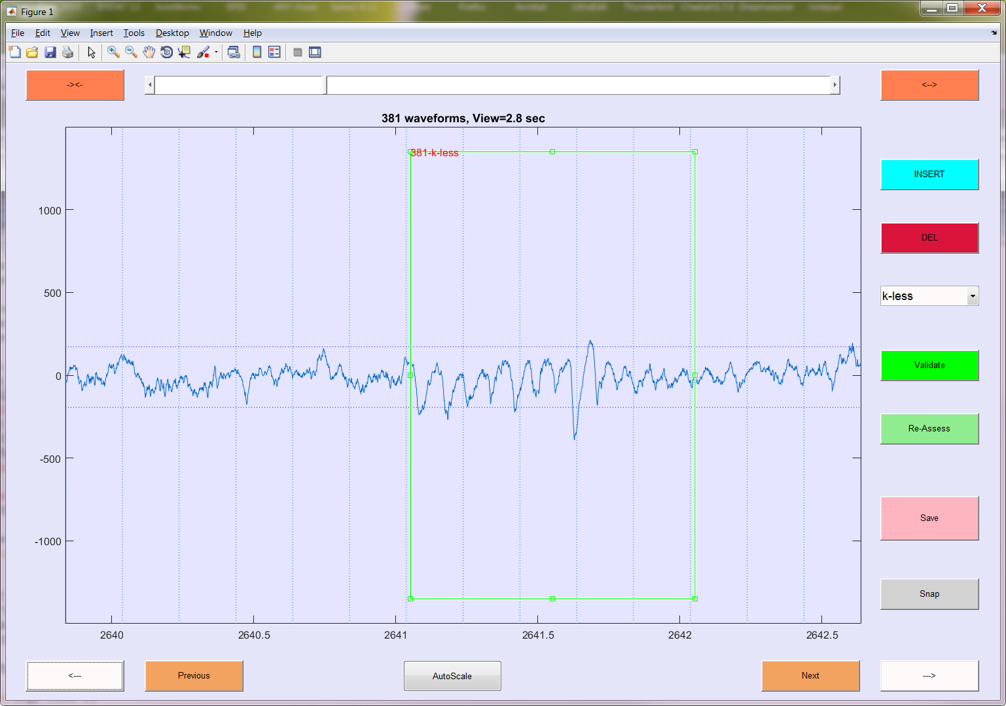

K-Less: A: No apparent (or ambiguous) K-complexes. More than 3 cycles of oscillations. If the first one is a K-complex, it is more than 400ms away from the oscillation (we count them separately). B: Note the oscillation before the start of the K-less boundary: Real (?), but too low frequency to be included. C: make sure not to include any trailing lower-frequency oscillations.

NOT a Spindle

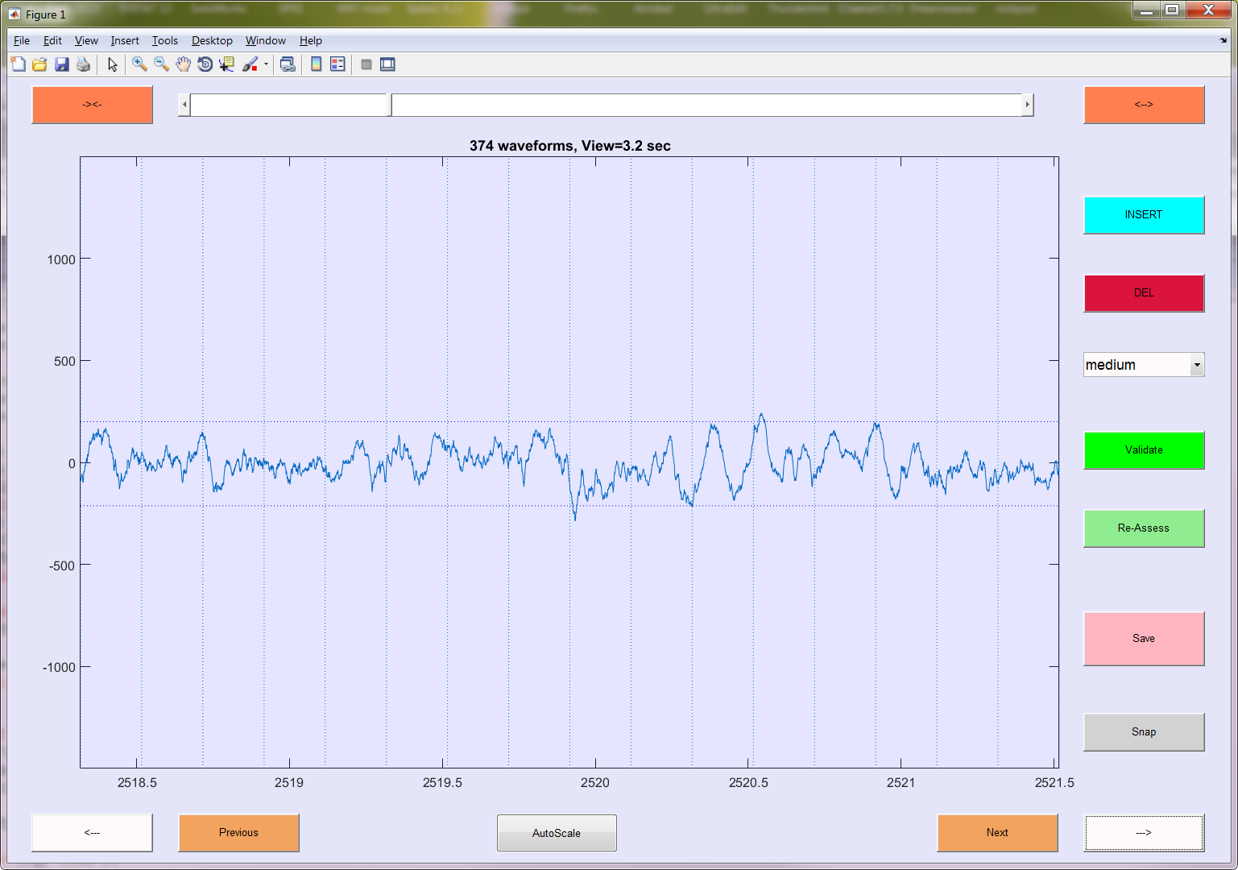 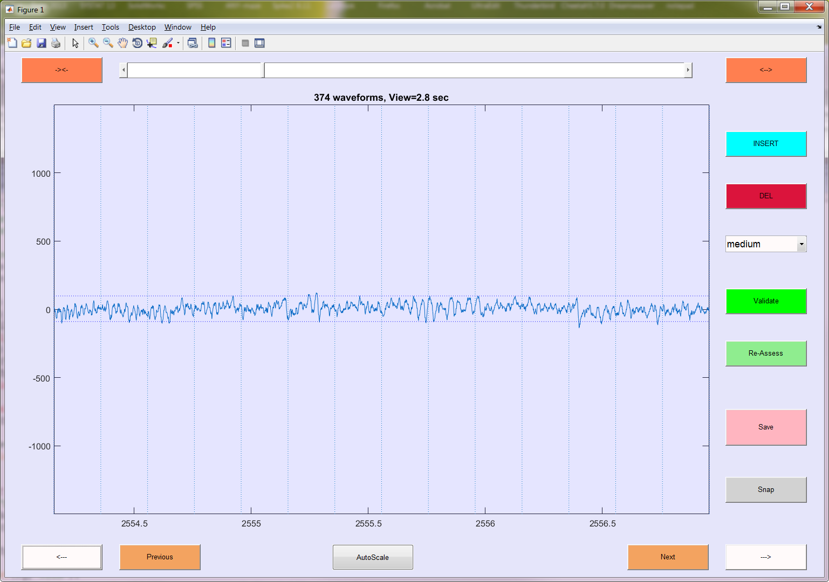

Not spindles: examples of traces that should not be mistaken for a spindle. A: interesting bout of oscillation, but wrong frequency (too low). B: also an interesting bout of oscillation, but wrong frequency (too fast)